MIDTOWNERS SUNSHINE OF THE WEEK ► November 14th, 2007
Birthday of PP Komal Chitracar on November 17th
Birthday of PP Gopal Kakshapati on November 20th
Birthday of Usha Pradhan, spouse of PP Niranjan on November 20th

SPEAKER OF THE WEEK ► Gregg Tully
THEME | The National Ambulance Center of Nepal: Introduction to the Program
Gregg has been in Kathmandu since March, volunteering for two projects. He has been working to establish the National Ambulance Center, a program of the Health Care Foundation - Nepal. Additionally, he is helping to create the Patan Academy of Health Sciences, a new medical school based at Patan Hospital that will train doctors to work in rural Nepal.
Gregg received his Ph.D. in Biology in 2006 at the University of California, Santa Barbara. He received his Bachelor's degree in Biology at Tufts University in 1998. From 1998 to 2000, he worked as a ski patroller at a ski resort, giving emergency medical care to skiers on the mountain. He became certified as an Emergency Medical Technician (EMT), which enables him to work on ambulances in the U.S., in 1999.

UPCOMING SPEAKERS ► PREVIEW
DATE | SPEAKER | THEME
Nov 24th | No Regular meeting | Charter Day Celebrations
Nov 30th | Mr. Peter Reid | Education Sector Reform (tentative)
Dec 7th | Dr. Saurav Dev Bhatta | Deadly sins of Statistical Misrepresentation in the Media

THE MID-TOWN CLUB ► NEWS
INDUCTION OF TWO NEW MEMBERS
Our club welcomed two new members to our family. Dr. Som Pudasaini and Mr. Pramod Poudel were formally inducted into Rotary on October 12. PP Ajay introduced new member Pramod Poudel and PP Komal introduced new member Dr. Som Pudasaini. PP William Ma and President Walter inducted the new members. The induction was greeted with a warm round of applause and everyone welcomed the new members to the Rotary family and wished them all of the best for their Rotary work with Mid-Town.

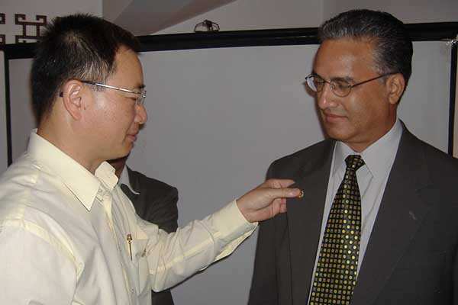  PP William putting pin on Rtn. Dr. Som Pudasaini | 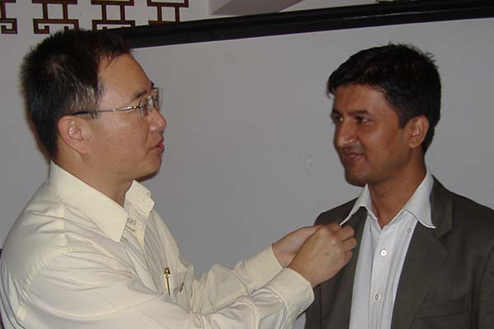  PP William putting the Rotary pin on Rtn. Pramod Poudel
Sight Test Project Report
Dr Chandra Lekha conducted 6 training sessions organized by the Rotaracts of Kathmandu Mid Town and one at Chitwan for 5 Rotary clubs and 5 Rotaract clubs. In total 4820 school children were tested by the Rotaracts, Interacts, school, family and volunteers, along with 602 for other clubs which has not been included.
Joint Meeting with RC Kantipur and RC Kathmandu West
On October 30, we had a joint meeting with RC Kantipur and RC Kathmandu West at Hotel Shankar. RC Kantipur was the host club. Mr. Darren Nance, Field Director of International Election Observation Mission at The Carter Centre, Kathmandu, was the special guest at the program. Mr. Nance began by saying that the previous day he had spoken personally with former President Carter and that President Carter sends his very warm regards. President Carter has very great respect for the work that the Rotary Clubs around the world are involved with and that Carter himself an Honorary Rotarian.
Mr. Nance went on to say that Nepal now has a historic opportunity to restructure the state along the lines of democracy and representation for all groups. He went on to say that all sides had agreed to many excellent agreements but that the real work will be in implementing them. To date there has been little accountability on all sides and that especially leaders needed to be held accountable.
More information is available at: Web site: www.cartercenter.org or from Mr. Nance’s office: 4445055

29 members from our Club were in attendance, the highest amongst all the clubs.
Well done, Mid-Towners.
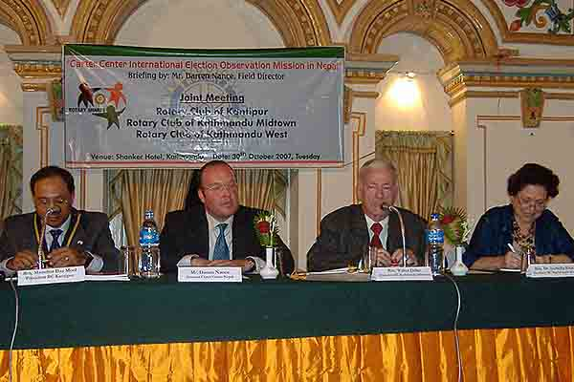  President MR Shrestha (RC Kantipur), Daren Nance, President Walter & Secretary Dr. Isa at the meeting | 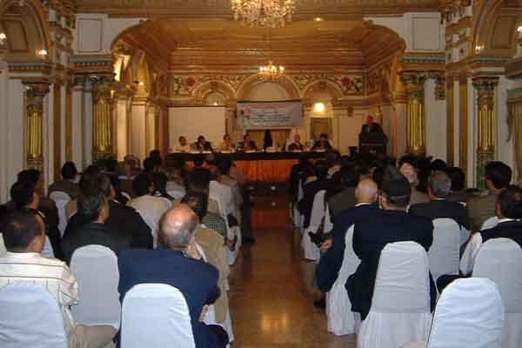  Mr. Darne Nance addressing the meeting

THE ROTARY INTERNATIONAL ► NEWS
Rotary International Crucial Ally in Advancing UN’s Goals
Secretary-General Ban Ki-moon has hailed members of Rotary International as allies in advancing the work of the United Nations through their global efforts in support of initiatives for health, literacy and poverty eradication.
“You have helped people understand what the UN is, what it does, and what it can do,” Mr. Ban told those gathered for the Rotary International Day programme held at UN Headquarters in New York on 3 November. “Ever since the United Nations was founded, you have been a wonderful partner to our organization.”
In a message delivered by Deputy Chef de Cabinet Kim Won-soo, the Secretary-General noted that Rotarians have been the UN’s “chief ally” in the mission to eradicate polio worldwide, helping to immunize almost two billion children around the world against the highly infectious, often paralyzing and sometimes fatal disease.
Rotary International has also worked with the UN to spread literacy and eradicate poverty, as well as sought to spread peace through its exchange programmes.
In those and other ways, Mr. Ban said Rotarians have advanced the work to reach the Millennium Development Goals (MDGs) the set of ambitious targets the world has set itself for slashing poverty, hunger, disease, illiteracy and other social ills by 2015.
He added that in his own native Republic of Korea, the Secretary-General has seen the remarkable work Rotary International has done in supporting the country for the past 80 years.

Editor: Rabi Karmacharya, Club Service Director email: rabikarma@gmailcom

----- Original Message -----
From: Rabi Karmacharya
To: Rabi Karmacharya
Sent: 15 November, 2007 17:02
Subject: BC Vol 14 07-08

Dear Mid-Towners.
Hope everyone is refreshed after the long Dashain and Tihar break. In case you did not get enough fun, we have our club's charter celebration coming up next week. We are planning a fun-filled afternoon. Mark your calendar for Saturday November 24th afternoon. We will email you the details soon.
YIR,
-Rabi
Club Service Director
Rotary Club of Kathmandu Mid-Town

